III. The Litvak Revolution: The Halakhic Roles of
Marital Communication and Erotic Imagination
in a Loving Relationship
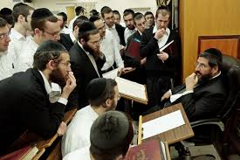

- When and Where Hasidim and Litvaks Parted Ways

- Ashkenazi Family Origins: Russian Jews (Litvaks, Hasidism) or German Jews (Yekes)? Geography and Religious Ideology
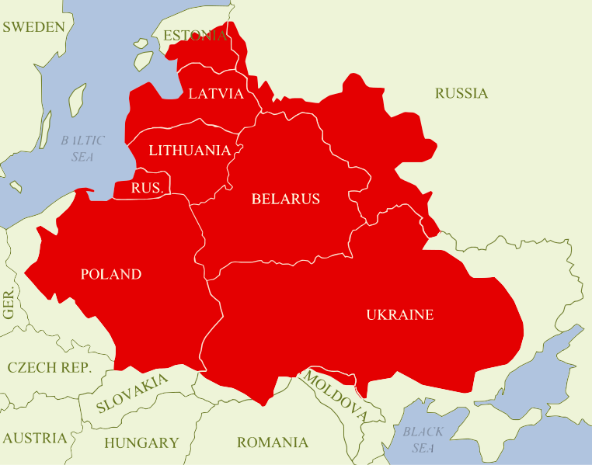

- Litvaks (Lithuania, Belorus, Latvia) versus Hasidim (Ukraine, Poland, Hungary-Romania)
- gefillte fish and kugel – savory or sweet?
- Talmud Torah or Prayer; study or practice; sober or enthusiastic?
- Lawful Punctuality or Mystical Kavanah (spiritual intentionality);
Torah-centered or God intoxicated
- Secret kabbalah for the elite or public dissemination of kabbalah?
- Intellectual elite or Spiritual Elite channeling divine blessing to masses
- Inventing the Modern Yeshivah or Inventing the Hasidic Court (Jewish magic, folk medicine, pastoral counseling, and the rebbe’s kvitlalkh)
- Will power and rational self-control suppressing the body and its desires (Mussar) or Hasidic emotional worship mediated through the body (group dance, whiskey, food at the rebbe’s tisch).

- Besht (Baal Shem Tov) (d. 1760): Avodah B’gashmiyut, Service of God through Corporeality
“It is better to serve the Lord in joy without self-mortification.”
“The soul cannot rejoice in the spiritual until the material has rejoiced in the corporeal.”
“[Penitential fasting] is the way of melancholy and sadness [because] the Divine Presence [Shekhinah] does not inspire out of sorrow, but only out of the joy of performing the commandments (simha shel mitzvah) (TB Brakhot 31a). As it says, Do not deny your flesh [Isaiah 58:7], God forbid, more than is obligatory or necessary.

- Litvak Gaon of Vilna: Be Cruel to your Family and the Ideal of the Scholar (Talmid Haham) (d. 1797) who inspired the First Modern Yeshiva founded by his disciple Haim of Volozhin and who excommunicated the first Hasidim as innovators

True heroes are men of noble heart with the fullest trust in God, constantly doing mitzvot and meditating on the Torah day and night even though their home be without bread and clothing and their families cry out: “Bring us something to support and sustain us with some livelihood!” But he pays no attention at all to them nor heeds their voice . . . for he has denied all love except that of the Lord and His Torah.
Rava says: “[Those who would possess Torah must learn from] the raven’s relation to its young to make themselves cruel to their children and their household members.” (TB Eruvin 22a)
- The 20th C. Litvak Reaction (1950s)
to Gur Hasidism’s Ordinances of Kedushah = Sanctity (1948)

- Hazon Ish (Avraham Yeshaya Karelitz): Torah’s Obligation to Make Your Wife Happy (1951):

- The Torah’s Honeymoon-Year Exemption from the IDF
When a man takes a new wife, he shall not go out with the army … He shall be exempt, free to be at his home for one year and make his wife whom he took happy. (Deut. 24:5)

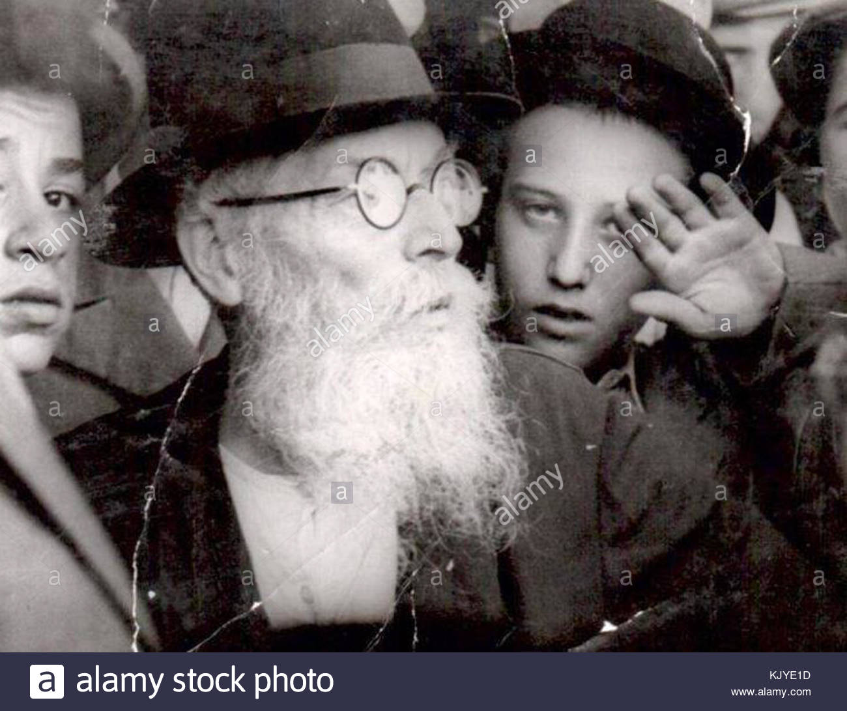
- [What makes a wife happy?]
Her nature is to find joy in the way she finds favor in [her husband’s] eyes and her eyes are directed to him [expectantly]. Therefore he must make an effort to show her love and closeness in words of conversation and appeasement.

- [The Value of Small Talk].
He [the husband] must make an effort to show her love and closeness in frequent/abundant conversation and appeasement. He should tell [his wife] whenever he leaves [the house] where he is going, and, upon his return [to tell her] what he has done, and other little things and words of reinforcement—to make her heart happy.”

- [Intimacy Transcends Respect]
Sometimes, treating one’s spouse with respect and with the awe of politeness displays lack of intimacy (closeness). One must relate with a greater intimacy than can be accommodated in a relationship of respectful honor. Levity and light-headedness (kalut rosh) are more loveable than seriousness and awesome honor. One must make every effort to behave in a more intimate way and draw her closer with one’s right hand rather than pushing her away with one’s left. . . . One should address [her] in the familiar singular (you), not the formal plural [characteristic of polite speech in Yiddish].
- Rav Moshe Aharon Shohatovitz: A Woman’s Emotional Connection

A woman’s erotic nature functions in a way the opposite that of the man’s, for he can start with the sexual alone and be satisfied with that alone. “A woman must first be aroused with an emotional connection and only later physically... If a husband functions only on the physical plane, then he may indeed feel satisfied, but his wife will feel degraded and despised and the whole relationship is one great experience of coercion, of suffering.”

A woman’s satisfaction comes not from the sexual act itself but from the connection between them. When she sees they have a full relationship of love during the whole month, then the mitzvah of onah is the center of that relationship and thus gives her satisfaction.... Without that [ongoing emotional intimacy in daily life] she experiences intercourse as a painful coercion (inui) and a stinging insult. For her the mitzvah of onah begins long before the act and finishes long after it.

- Rav Raphael Menahem Shlanger (Litvak Ultra-Orthodox Educator), Mishkan Yisrael (1991): When Onah (Marital Intercourse) becomes an Act of Prostitution
The Rabbis listed the nine major dimensions of failed intention [and emotionally defective sexual relations] in marriage [such as intercourse under threat of the husband, intercourse when the couple is quarrelling, intercourse when thinking of another woman, intercourse despite the husband panning to divorce his wife etc] . (TB Nedarim 20b)

All of them can be reduced to one dysfunction – separating the act of intercourse from the covenant of love between man and woman. Then the act does not flow from love and its purpose is not to unite a husband with his wife and to complete a wife with her husband. Such a union that does not actualize the covenant of marriage, but it is simply a physical act similar to prostitution.

- Rav Isaac Sher: Educating Haredim to Feel Erotic Passion and Sexual Desire

The virtue of love “is not properly developed among us [the haredim].” Therefore the couple must learn to speak words of love, “for surely, this love is natural, and it is a mitzvah to enhance and develop it properly.” “When the couple comes together, the husband must address his wife in a way that conveys not only ‘awe, piety, and chastity,’ but also tenderness, affection, and erotic love (agavim) … The husband must speak to his wife explicitly even ‘about her [physical] beauty.’”
Then Sher quotes: Rav Isaac of Acco (13th-14th C. Spanish Kabbalist): “Anyone who has no desire for a woman is like a mule or less than that. For one must discern the worship of God even in the senses.” (Eliyahu de Vidas, Reshit Hokhma)

- Bridal Counselor: Liberating Haredi Brides to Sexual Agency and Desire
(Orthodox woman scholar counseling brides cited by Rav Shlomo Aviner, 1970, Etzem MeiAtzmai):

“Many brides are very anxious about the physical ties because they do not know what will happen. Hence they are afraid. Therefore women [bridal counselors] are obligated to explain to them exactly what will happen... There are inner restraints about talking about these topics and it is hard to unburden oneself from the shame. But the reality shows that brides are very pressured about this and that causes crises.
A woman also needs to make an effort to enjoy the physical connection. She must be very liberated (m’shuhretet) and cast aside all psychological restraints. She should not be passive and she must know that too belongs to Judaism.
Sometimes the girl is very delicate, pious and modest, and then the man feels bad and he does not reach (sexual) satisfaction. He feels that he is evil and uncouth and then he gets angry, nervous, and tense. Finally, he pours out his wrath on his wife without really knowing what he is doing...
Many women cannot understand that a student of Torah [like their yeshiva husband] can be such a man of desires. But she should not be upset and she should not give him a sense that he is not normal.”
(See Appendix: In the Boudoir with Orthodox Jewish Photographers)

- Rav Isaac Sher (Litvak Yeshiva Mussar Educator, 1951): Exposing the False Piety of “Holier-than-Thou” Hasidim and Dysfunctions of their Families
I have heard that some of those who pretend to be God-fearing and pseudo-hasidim (pious) take great care to fulfill this mitzvah for the sake of Heaven and without feeling any biological desire. Such a person busies himself half the night with Torah and prayer . . and only then, after midnight, he comes home, wakes up his wife, prattles to her, to placate her so she will consent to fulfill the mitzvah [in the middle of the night]. So she allows him to do with her as he pleases for she knows from her mother that such is the behavior of pious men.

Afterwards he is proud of having managed to fulfill this commandment without [succumbing to] the evil inclination, [namely], without any impure lust. But later he wonders why the sons he has produced in this way have turned out to be wicked or stupid!

Surely, the reason is his false belief that it is wrong to perform the commandment [of onah] with desire… [Rather the truth is that] when intercourse takes place without the wife’s full consent or desire, that is, when she would rather be asleep and she is angry with her husband for disturbing her and doing with her as he pleases rather than as she pleases, then he is violating a Torah prohibition. This is a grave error and it gives rise to numerous problems: the wife loathes her [so-called] ‘righteous’ husband and quarrels with him. [The explicit contents of her complaints] are about other issues, of course, for she is embarrassed to tell him what really upsets her and what she really misses. [In this family] there is no harmony (shalom-bayit) in the home, and the children are neglected, deprived of a good education on account of the quarrels. May God have mercy upon them.” (Sher, Kedushat Yisra’el, The Holiness of the Jewish People)

- The Role of Conversation in Marital Harmony:
From Rabbinic Prohibition to Biblical Obligation

The Dangling Conversation by Simon & Garfunkel 1967
Shadows wash the room and we sit and drink our coffee
Couched in our indifference…..In the dangling conversation and the superficial sighs
The borders of our lives and you read your Emily Dickinson and I my Robert Frost
And we note our place with book markers that measure what we've lost
Like a poem poorly written we are verses out of rhythm, couplets out of rhyme
In syncopated time and the dangling conversation
And the superficial sighs are the borders of our lives
Yes, we speak of things that matter with words that must be said….
And I only kiss your shadow I cannot feel your hand
You're a stranger now unto me lost in the dangling conversation
And the superficial sighs in the borders of our lives
https://www.youtube.com/watch?v=k3Ij_UapnwE
- A Talmudic School of Opposition to Conversing with One’s Wife
Yossi ben Yohanan says: “Do not converse too much with the woman, not even with your own wife.” (Pirkei Avot 1:5) – [especially not during intercourse TB Nedarim]

- Hazon Ish (1951): The Mitzvah of Small Talk
The rabbinic prohibition, “Do not be expansive in talking . . . even with one’s wife” does not apply when appeasing one’s wife before intercourse or during the first year of marriage when one must strive to be united [with one’s spouse] which is the purpose of her creation: to become one flesh (Gen. 2:24). Only then the Rabbis say the Shekhinah will dwell [between them].
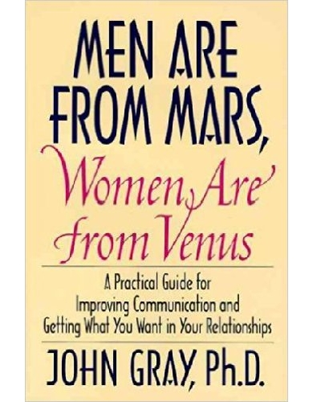

- Rav Moshe Aharon Shohatovitz (2003): The First Year Conversation:
Beyond Small Talk and Affection to Mutual Learning from Each Other’s Unique Perspective
“The Torah established that the only way for a person to be complete and not a mere half is to be united as a man and a woman in marriage. So during their whole lives lived in mutuality, each must learn about the other half. The result will be a whole human being – a person who has both a male and female perspective on the whole of Creation....
However what happens in reality instead of a man learning the female perspective on the Creation, he insists stubbornly that he remain in his narrow male perspective even after marriage, and he misses the main purpose of marriage. As long as one has not emerged from the small viewpoint of one person, one is still in the beginning stages of marriage...
The first year is a full year of work to become acquainted with the other side of the coin. In fact our Rabbis have taught that a year is only a minimum time frame for such work, and only the greatest human beings, like Aaron the High Priest, can accomplish this end in one year. Most take two years and in our [fallen] generation if it takes five years that is not bad. But one who wishes to be ‘a full human being’ must do this; otherwise you are missing the whole point.... which can only be done by a complete union with the woman, “your covenantal marriage partner” (Prophet Malachi 2:14) ... (Binyan HaBayit, 31-32)

- Rav Shlomo Aviner (Israeli Hardal, Rightwing Religious Zionist, student of Rav Kook’s son): The Mitzvah of Listening to One’s Spouse

In the first year of marriage one must dedicate special attention to this issue because the bride and bridegroom do not know one another very well and they haven’t assayed their mutual expectations. This obligation falls in particular on the bridegroom since his new wife’s form of life has changed much more than his. Generally she has been cut off from many more of things that made her happy when she was single. ...

But it is not so simple to know what truly causes the other joy. Beware of those who say what they think one ‘must’ do to make the other happy and if the other is not pleased by them then s/he must be completely stupid... But no one can decide for the other what will make the other happy. Rather one must listen humbly to what the other says and from that to conclude what the expectations are. .. Each person has an inner world of joy and sadness, of ambitions and desires, that is the world of the ‘I.’ No one else is permitted to belong to that inner world. This cannot be done at a distance in a theoretical way. It comes only from frequent and living encounters. Hence one must be ‘free to be at home a whole year.’ From that one may hope that each one will learn how to make the other happy and to pour the foundations of a lasting marriage. Always they must inscribe in the depths of their souls the aspiration to make the other happy - with one’s whole heart and soul.”

- Rav Shlomo Aviner: Verbalizing Sexual Issues
“If there is some incompatibility, then the couple should converse together out of love and affection to reach a solution. While some think it is prohibited to speak with one’s wife about these matters because it is immodest, that is a mistaken view. ... It is all part of the mitzvah to enhance love and peace.” To learn about sexual problems and to prepare for marriage, Rav Moshe Feinstein approves the reading of medical literature “to make sure his wife will have pleasure and to increase shalom bayit, domestic tranquility.”

- Rav Isaac Sher: Techniques to Reinforce Marital Love (Kedushat Yisrael) and the Halakhic Art of Erotic Lovemaking

- Every Month One Becomes a Newlywed Again
One should learn from the case of Rav that it is a mitzvah to act lightheadedly (kalut rosh) with one’s wife exactly as she wishes as if he were a bridegroom just emerging from the wedding canopy who had never had intercourse in his life. She wants [him to behave] that way, so that she too will feel like a bride at the moment of her wedding. . . . And that is the way they should behave their whole lives . . . as it says, I am to my beloved and my beloved is to me (Song of Songs 6:3)
A couple would be wise to keep a notebook (pinkas) from their wedding celebration and to record all the words of love and compliments they spoke to one another as loving companions from each day and night of the seven days of their marital festivities. Then they should reread them on the [monthly] night of the immersion.
- Rav Isaac Sher: God as Our “Best Man,“ Our Cupid, Our Matchmaker, Our Hairstyler, and our Party Planner
The Rabbis say that God planted in the heart of Adam and Eve feelings of love and beauty. Then the Holy One [like the best man, shushbin, who arranges the wedding] braided her hair and brought her to Adam. He and she were happy with her beauty. . . . Even today at every wedding the Holy One is the true shushbin, making the couple happy.
- Guided Imagery Therapy during Intercourse: Back to the Garden of Eden.
[The couple must] “imagine themselves in the Garden of Eden. Then the woman is filled with love and pleasure arising from sanctity and spiritual elevation so that when she reaches the apex of the act [of intercourse] she is fully intoxicated, hovering in the world of imagination. Then she dreams pleasant dreams illustrated with beautiful images of angels filled with light and radiance flying above her and feting her with the very same pleasures as in the Garden of Eden itself. So too the man can in this desire, in this act, and with this woman be filled with elevated thoughts and elevated illustrations of love and sanctity in their unification.

Rav Jacob Emden's Prayerbook (d. 1776): Lovemaking on Shabbat
“There is no copulation without preparing for it with hugging and kissing. There are two kinds of kissing: one before the sexual union is designed for the husband to appease his wife and to awaken the love between them, and then there is kissing during the sexual union .....”
“First, one helps make one’s wife’s mind achieve tranquility and then causes her joy and nourishes her with words/things that cause her heart joy in order that she will experience desire for him. That will be apparent to him by attending to her breathing and [the light in] her eyes. Then they make love to one another.” “Intimacy should come as the climax of hugging and kissing.”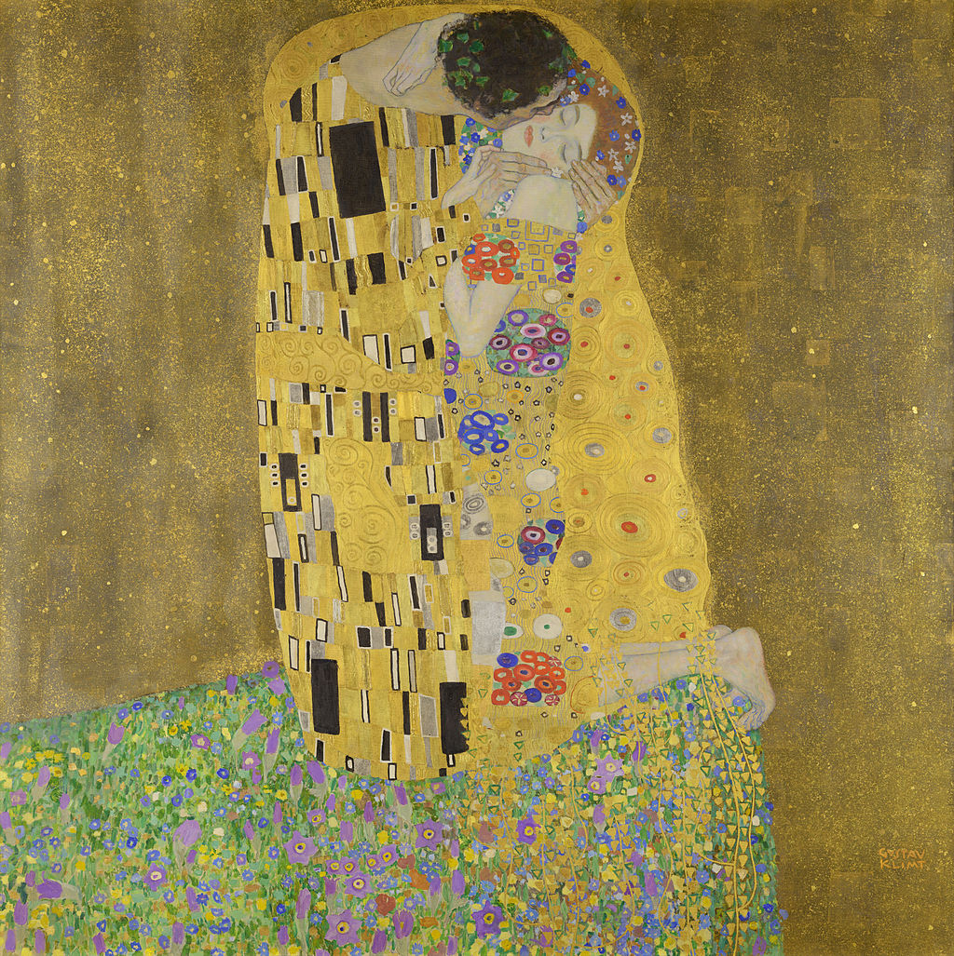Gustav Klimt, “The Kiss” (1907)

CODA: On the Sanctity and Divinity of Sexual Union in Marriage

Zohar – The Image of God: Male and Female Together
- "Male and female God created them, blessed them and called their name Human (Adam)" (Genesis 5:1-2)

- A human being is only called Adam (human) when male and female come together…..The Blessed Holy One does not place the Divine dwelling [Shekhinah] in any place where male and female are not found together. Blessings are found only in a place where male and female are found. … (Zohar 1:55b).

- My Teacher Rav Menahem Froman: Photographing the Shekhinah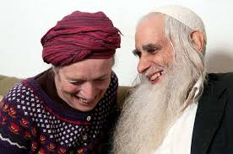

Homework for Marital Intimacy

Rainer Maria Rilke, Austrian Poet:
“Those who love must act as if they had a great work to accomplish.”

Wooing Your Wife like a Rooster Courts a Hen (4th c. Babylonia) (TB Eruvin 100b).
The Rabbis idealize the courting behavior of roosters as a positive model to emulate:
“A rooster woos/appeases/courts [the hen] before performing intercourse,” as one sees when the rooster prances before the hen, stretches his wings, and scraps his feet.

- Esther Perel, couple therapist: “Seducing my partner?” (educated in Hasidic Antwerp)
"If you don't want sex to be another item on your to-do list, don't treat it like one. I'm not talking about scheduling sex, I'm talking about creating an erotic space and that takes time. What will occur in that space is open-ended, but the space itself is marked by intentionality.”
“Quite a few of my patients balk at the idea of deliberateness when it comes to sex. They find these strategies too laborious for the long haul, believing they should no longer be necessary after the initial conquest. ‘Seducing my partner? Do I still have to do that?’ ‘Why should I? You're supposed to love me no matter what!’”
"Just because you live with someone doesn't necessarily mean he's readily available. If anything, he requires more attention, not less. If you want sex to remain humid, this is the kind of attention you have to bring to it.”(Mating in Captivity)
Appendix: In the Boudoir with Orthodox Jewish Photographers

In her article, “In the boudoir with Orthodox Jewish women” (The Guardian, Sept. 2, 2015), Debra Kamin explores the use of photography in the cultivation of sensuality among contemporary Orthodox brides and wives. She reports on a recent development of sensual portraiture as an increasingly popular genre among Orthodox women. Perhaps her discoveries echo Rav Hisda’s insight that one must instruct the pious daughters of Israel about making themselves more erotic in their sexual encounters with their husbands. Orthodox women cannot become good sexual partners without knowledge, self-esteem and a strong religious mandate to become better lovers.

Kamin describes an Orthodox wife, residing in an Orthodox settlement in the West Bank with four children, who hired a female Orthodox photographer to create an erotic album for her husband:
A is a 30-year-old mother of four. In accordance with Jewish custom, she covers her hair with a hat or scarf, and wears modest clothing that doesn’t reveal her knees, shoulders or cleavage. Today [in her photo shoot], however, she looks different. Dressed in a lacy black negligee, her hair styled in loose waves and her eyes done up with smoky powder, she lounges on a bed in an apartment in suburban Jerusalem and gazes coyly at a photographer’s camera. “Come closer,” the photographer, Rebecca Sigala, says to her. “Imagine the lens is your husband, and give him a smile.”
Kamin explains the context:
“A has purchased today’s boudoir session as an eighth anniversary gift for her husband. The photos will be presented to him in an album and remain private between the two of them. The shoot begins with hair and makeup…a number of lacy nightdresses, and even one of her husband’s unbuttoned dress shirts. But while she thinks he will be delighted by the photos, she says she wouldn’t want anyone in her community to know about the experience. ‘It’s simply too private. Intimacy is something you share just with your husband.’”
The Orthodox boudoir photographer explains the religious orientation behind her profession:
“As observant Jews, we believe our sexuality is private and sacred. And since that part of ourselves is so holy, when we express ourselves within that realm, we can connect on a higher level – not just with ourselves, but with our husbands and with God.”
This Israeli wife, who was photographed in provocative clothing and positions, says: “It’s something I want to be able to tap into. It’s about the experience I am having today, and being able to know that I’m sexy. I can lay here on the bed and feel beautiful, feel shalem [whole, or complete].”
Orthodox women who turn to these photographers want to develop their own sacred sensuality, but they also want to enhance their sexual connection to their husbands by cultivating their erotic beauty.
The halakhic basis for this concern to make themselves more attractive to their husbands is well-grounded in Rabbi Akiba’s policies about maintaining a wife’s beauty. Rabbi Akiba, in contrast with the “early elders,” made allowances for wives to keep their husbands’ attention. He says, as we mentioned above, that a menstruant woman may put on eye-shadow or rouge and adorn herself with colorful clothing even during the time of her menstrual impurity. Otherwise, her lack of beauty “will lead to contention, and the husband may want to divorce her.” Rabbi Akiba himself ruled that should a husband find another woman who is more attractive to him than his present wife that he has legitimate grounds for divorce. Therefore he made lenient halakhic decisions to make it easier for wives to maintain their allure.
“I don’t care what religion you are — if you don’t keep your husband excited, someone else will,” says Malky: “It’s not against Halakha [Jewish law] to keep your husband satisfied.”
An Orthodox boudoir photographer from Brooklyn says her photo shoots sometimes double as therapy sessions: “For frum women, it can be extremely difficult to perceive themselves as beautiful. They’re always having babies, or their friends are having babies and they can’t, and they feel their bodies are somehow damaged. But everyone is beautiful in their own way, and by the end of the shoot, they can see themselves differently.”
A Jerusalem photographer of Orthodox wives concurs with this therapeutic perspective on her profession: “There are a lot of misconceptions within the religious community, and there are women who feel trapped by those misconceptions. This can open their eyes to realizing that they can be religious, modest, and beautiful daughters of Hashem and still do something like this.”
It is likely that Orthodox men need their own therapeutic instruction in order to become better lovers and to fulfill their halakhic mandate to arouse their wives to perform onah willingly and to satisfy their wives’ sexual needs.

Mystics Protest against Maimonides’ Philosophic Denigration of Physical Love: The Holy Letter (13th C. Spain): “Know that connection (sexual intercourse) is holy and clean when done properly at the right time and with the correct intention. No one should think it is detestable or ugly… Maimonides is wrong in praising Aristotle for calling the sense of touch our source of shame. God forbid, the Greek is not correct…. Rather all those who possess the Torah believe that God made everything according to Divine Wisdom and nothing was created to be condemned or ugly…If our sexual organs are detestable, how could the Holy one create something that is lacking or condemnable, God forbid? …The great secret of the cherubs is that they were intertwined one with the other in the likeness of a male and female.”
Zohar elucidates: Come and look what it says: Adam said: “This time!” (Gen. 2:23)—These words of pleasantness, like a fragrance, draw her in affection and draw her to fulfill his desire and to arouse her to love him. Look how these words are filled with perfume, how many words of love such as bone of my bone, flesh of my flesh—show they are one and there is no separation between them at all. Now he begins to praise her: This shall be named “Woman”—“She is incomparable! She is the most precious one of the household. In her presence all other women are as monkeys compared to humans, but she is complete perfection. This one and no other!” . . . All sorts of words of love [that Adam speaks to Eve] . . . draw her in love, so she will cleave to him [as it says, therefore a man will leave his father and mother and cleave to his wife and become one flesh.” (gen. 2:24)

