II. The Dark Side of Rabbinic Judaism:
Rabbi Eliezer and Imma Shalom’s Bedroom Modesty and the Contemporary Hasidic Ideal of Ascetic Marriage
versus
Reform Judaism’s New Vision of Marriage
as a Covenantal Partnership of Lovers

Memoir of Training for the Hasidic Groom among Skver Hasidism

- Shulem Deen, All Who Go Do Not Return: A Memoir

- At New Skver Hasidic Village, NY State I attended classes for the Hasidic Groom with Avremel. Avremel would cry during those sessions: “‘Respect her more than your own self!’” quoting the Talmud which teaches “One should love his wife as much as himself/his own body and honor her even more than himself/his own body.” (TB Yevamot 62b; Sanhedrin 75b)].

“But, Avremel would ask: “How do we understand this passage? … What it really means, esteemed young men, is that we must be vigilant! Respect what she, a woman, can do to a man if he does not remain careful.” He would wag an index finger over his head, “Let down your guard, and she will lead you into sheol tachtis—the abyss of sinful temptation!” …

- The Groom’s Jitters:
When the session was over, I waited until the others left, and then asked Avremel: “I am not happy. ... I just don’t think she [my bride] and I have anything in common.”
Avremel said, “You were hoping for a friend…. A wife isn’t a friend…. A wife is to be a helpmate (Gen. 2:18). Your friends will still be your fellow students.”

I had misunderstood the whole marriage thing, he said. A wife is not a friend. A wife is not something to think about excessively. To take a wife is a biblical commandment, and so we do God’s will by taking one. A wife is there to assist with one’s service to God, nothing more.

- Last Minute Instructions
My wedding day arrived a month before my nineteenth birthday. At three o’clock in the afternoon, I was to meet with the last of all groom instructors, Reb Shraga to learn the mechanics of how to perform “the mitzvah.” …
He opened a large volume on the table and read aloud: One who marries a virgin takes possession of her, and separates from her immediately. Then, at last, he described the mechanics of the sexual act. He used a series of hand gestures, and finally I understood, more or less.

“Before the act itself,” Reb Shraga said, “lie beside her and chat for a few minutes.”
“Chat about what?” I asked.
“Doesn’t matter. Any tale about a righteous man…. Then you get on top, and tell her you love her.”
“How?” I asked simply, and the question felt stupid on my lips.
“Just say, ‘I love you.’”

The notion of loving my wife had never occurred to me. Marriage was a duty, no more. To pretend otherwise seemed ridiculous. But “the law says you must tell her you love her.” There was no arguing with the law.

Most important of all, the mitzvah must be done the way it was done by the great sage Rabbi Eliezer: with awe and with fear, as if forced by a demon.

“Mazel tov,” he said. “If there are any problems, call me.”

- Technical Difficulties:
At three in the morning, we arrived home to our new apartment. We fumbled our way into bed, moving about each other shyly as we adjusted to this unfamiliar intimacy. We needed more guidance. I hesitated but made the call anyway. It took several tries that night and a couple of nights after, with several more consultations with Reb Shraga.

Talmudic Model: Modesty in the Bedroom of Imma Shalom and Rabbi Eliezer

- Imma Shalom’s Homespun Advice on Eugenics

They asked Imma Shalom: “How do you merit such particularly beautiful children (sons)?”
She answered: “[My husband, Rabbi Eliezer] does not have intercourse [literally. “talk” (m’sapeir)] with me - neither at the beginning nor at the end of the night, but only around midnight.

I once asked him: Why [do we always have intercourse at midnight]?
He answered me: “So that I do not direct my eyes to another woman!”
That way his children would not become mamzerim / bastards.

Then, when he is having intercourse, he uncovers only a handbreadth and then he covers over a handbreadth. He acts as if a demon were coercing him [to have intercourse].” ” (TB Nedarim 20b)

Rabbi Eliezer teaches: “One should always flee from ugliness and from whatever is similar to ugliness.” (Tosefta Hullin 2:24)

- Medieval Halakhic Debate:
Legislating according to Rav or Eliezer’s Bedroom Protocol

Maimonides (12th c. Egypt) legislates in accord with Rav:
“A husband: shall not coerce her and force her into intercourse against her will (i.e. rape), but rather let him seek her consent as an outcome of conversation (sikha) and joy (simkha)” (Maimonides, Laws of Marriage 15: 17).

Maimonides also recommends Aristocratic Self-Restraint in accord with Rabbi Eliezer: The Scholarly Gentleman (Ben Torah) and the Ladylike Wife
- “Even though intercourse with one’s wife is permitted at any time, a scholar should behave with sanctity and not have sex as often as a rooster ... He should not behave lightheadedly and should not be foul-mouthed ... even in intimate relations between him and her.” (Character Traits 5:4)
- “A woman should be modest at home, minimize laughter and light-headedness in the presence of her husband and she should not verbally demand sexual satisfaction of her needs.” (Marriage 15:18; see Forbidden Intercourse 21:13)

Dr. Maimonides’ Prescription: Healthy Intercourse by Doctor’s Orders Only
“When one has intercourse, it should only be to make one’s body healthier and to produce surviving seed. So one does not have intercourse whenever one so desires but only when one knows one must express seed for medical purposes and to procreate.” (Character Traits 3:2) The Rabbis praise that intent, they love it and they call that intention “sanctifying oneself in the act of intercourse.”

Semen is the power of the body, of his vitality and eyesight, and the more one expends semen, the more the body decays, one’s power dissipates, and one’s life force is lost. . . . When anyone is profligate in intercourse, old age springs on him prematurely: his strength decreases, his eyes grow dim, bad body odors waft from his mouth and armpits, his hair, eyebrows and eyelashes shed, his beard and body hair become abundant, his teeth fall out, and his aches and pains increase.

The wisest of the doctors [Hippocrates?] says: One in a thousand dies of illnesses, but a thousand from excessive intercourse. . . . So beware if you wish to live a good life. …

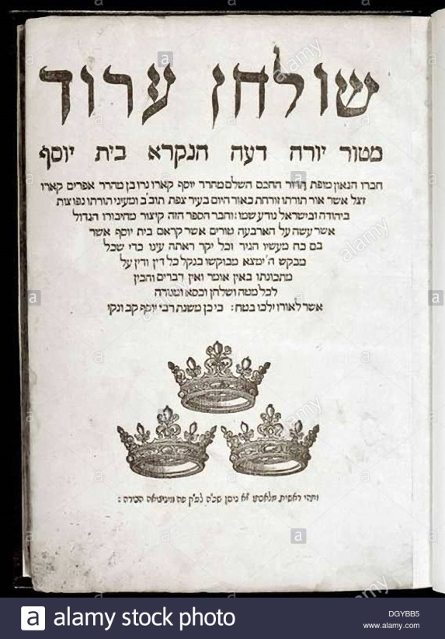
- Rav Yosef Karo (The Code of Jewish Law, Shulhan Arukh (1565) legislates according to Rabbi Eliezer:

- “Engage in intercourse with fear and awe just as it says of Rabbi Eliezer… Even when one is having intercourse at the time of onah, one should not intend to enjoy himself but rather he should think of himself as one who is just paying off a debt for he is obligated to provide onah [to his wife].
A person should accustom himself to extra holiness, purity of thought, and proper character . . . Therefore, he should avoid levity, drunkenness, and erotic words. (Even HaEzer 25:4)
- Hasidic Rebbes and Marital Intimacy

- Maggid of Mezritch: Rebbe Dov Ber (d. 1772)

“One should love one’s wife only in the way one loves one’s tefillin, namely as [an instrument for fulfilling] commandments of God, but one should not think about her. She is [merely a means to serve God] just as in the analogy of someone traveling to the market who needs a horse. But does he love the horse?! . . . So too in this world a man needs a wife in order to worship the Creator in order to earn his place in the world-to-come. But should he leave aside his work and think about her? Nothing is a greater foolishness.

- Rebbe Shneur Zalman of Liadi (Belarus, 1745-1812), a disciple of the Baal Shem Tov and the Maggid and the founder of Chabad Lubavitch Hasidism:

The mystical Hasidic reason for “waging war against [the pleasures of] his body and the animal soul within it . . . is in order to crush them, and to beat them into dust.”

“A completely righteous man” [tzaddik] . . . has completely removed the filthy garments of evil, [and he is] utterly repulsed by the pleasures of this world and by men taking pleasure in gratifying their appetites instead of serving God—for these are drawn from, and flow from, the [evil] shells and the [evil] Other Side.” (The Tanya, 1796)

- Rabbi Nahman of Bratzlav (d. 1810), the great-grandson of the Baal Shem Tov, reported that he experienced pain rather than pleasure in the act of intercourse:
“Copulation is difficult for the true zaddik [i.e., spiritual virtuoso or Hasidic rebbe]. Not only doesn’t he have any desire for it at all, but actually from that act he has real suffering like the suffering of an infant during circumcision. The very same suffering, to an even greater degree, is felt by the zaddik during intercourse.”

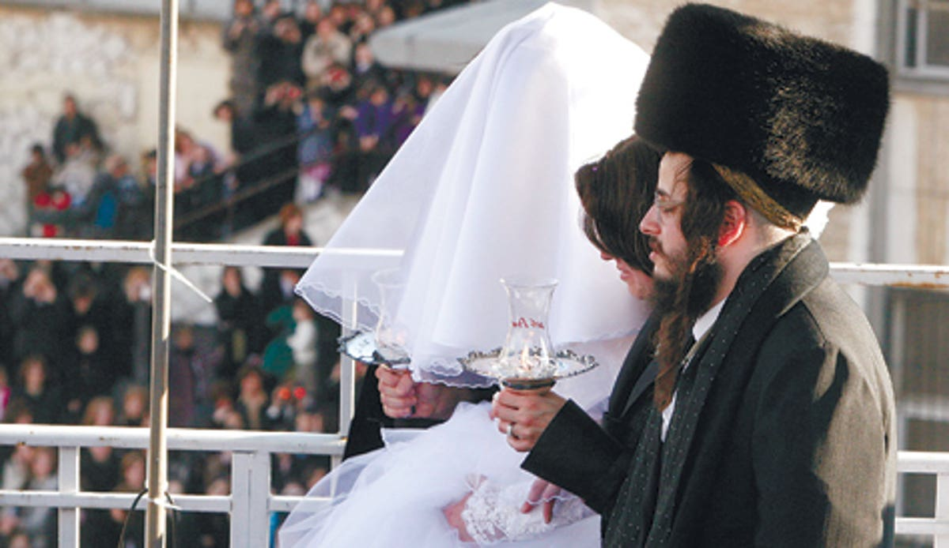

- Gur Hasidim: The New Normal is “Voluntary” Sexual Abstinence in Marriage

The Unpublished Ordinances on Holiness in Marriage (Israel after 1948) of Gur Hasidim
FREQUENCY of Onah (Marital intercourse):
The couple shall have sexual intercourse only once a month, on leil tevilah (the night after the wife’s immersion in the mikveh at the end of her halakhically prescribed menstrual period).
QUALITY of Erotic Intimacy:
During intercourse, the couple shall aim to minimize physical contact. The husband shall wear some of his clothes, including his tsitsit (considered a segulah—supernatural remedy—against the sexual drive) and will not hug or kiss his wife or engage in any behaviour that is not required for the performance of the act of intercourse itself.• The husband shall direct his thoughts as far away as possible from the sexual act.
SOCIAL DISTANCING with YOUR SPOUSE: Never walk alongside one’s wife in public but keep a distance of at least four cubits (about two meters) or sit next to her. The husband should not address his wife by her first name.”

Rebbe Sholom Noach Berezovsky, the Slonimer Rebbe (1981-2000)

The Pep Talk for the Groom in the First Year of Marriage – Preparing for a Spiritual Battle for Sanctity and Heroic Abstinence on the Frontlines of the Sacred Bedroom

- The Bedroom as the Sacred Battlefield: “Husband and wife—the Divine Presence (Shekhinah) dwells among them; their home is like a minor Temple . . ., their table is like an altar, their bed is like the Holy of Holies, and he [the husband] is like the High Priest who enters its innermost part to offer sacrifices.”

- The crucial first year of marriage as the time of testing by Satan: “Now that you are a married man, I see that once again, you stand alone, engaged in a raging battle that is even fiercer than the previous one [when unmarried]. For in that [first battle, i.e. before marriage], it [sex] was prohibited, while in this [second battle, i.e. within marriage], it is permitted.

Many have already been slain, and many others will be slain [in this battle]. Only the elect few, whom God has preserved and planted in every generation, can emerge from it [unharmed] and gloriously victorious. I pray that you, my beloved, will be among them.”

- Pep Talk for the Heroic Soldier: “When confronting the enemy face-to-face, rational argumentation is of no help . . . One should know how to act as a faithful soldier who is willing to die for the sake of victory, not sparing either his own life or that of his wife and family members. Self-sacrifice, blood, tears, and sweat are required, . . . for a life of happiness and joy is a life of abstinence and purity…. [As the dying King David said to his son Solomon]: Be strong therefore, and show yourself a man (I Kings 2:2)—a man, and not a woman.”

The Spiritual Vocation of the Women of Hasidut Gur:
“Who is a kosher wife? One who does the will of her husband.”

- As the couple approaches their first night together and their first night relating to their own bodies as a sexual object, they have reason to be anxious. Neither husband-to-be nor wife-to-be have been taught anything about the laws of intercourse or menses or about the physiology of their body until just before the night of their marriage. Not until the very day of the wedding itself is intercourse itself discussed.

The counselor reassures the bride: ‘Give yourself to this mitzvah and then your children born of this night will willingly give themselves to a life of mitzvot.” M’sirus nefesh, willingness to martyr oneself, is the hasidic ideal, not standing up for your rights and getting what you need out of a relationship. The counselor promises that with God’s help you can “break human nature” and its impulses and “sanctify yourself by [abstaining even from] what is permitted.”

- the obstacles to martial communication
In the realm of interpersonal communication neither the bride nor the bridegroom has any experience in dialogue with the opposite sex, nor are such communication skills valued either before or during married life. After marriage the husbands still maintain distance and minimize intimacy both sexual and interpersonal lest the spirituality of their homes be disturbed. The less time a husband stays at home with his wife, the better.
For Gur, conversations between spouses should be reduced to practical issues minimized so as to convey information and instructions without emotions, hopes and fears. Husbands are discouraged from conversation with their wives, but are instead instructed to issue commands which wives are expected to obey. It is the wife’s task to defer to male decisions which are not accompanied with explication or persuasion.
In Gur no value is placed on investing time or effort into the needs and feelings of the self or into the marital relationship. What is needed is spiritual discipline, repairing one’s selfish traits, controlling one’s impulses, and appreciating whatever God has given us. God is the ultimate matchmaker of each couple
- gendered division of labor in the Gur household
Women are taught to live up to the rabbinic adage, “Who is a kosher wife? One who does the will of her husband.” A good wife nullifies her will before her husband’s, just as a hasid nullifies his will before the Divine will. A wife must accept submission to her husband’s rule in all matters both religious and economic in order to fulfill God’s curse on Eve that “he will rule over you” (Gen. 3).
A woman’s role is to receive and a man’s is to give (mashpia). The daughters of Gur are taught that the spiritual blessings (shefa) come to them exclusively through their husbands, just as the blessings for all Israel come through the rebbe. The woman is not called a hasida, but only the daughter of or wife of a hasid, since she has no direct relation to the Divine or to the Torah.
Hasidic Couple

Rabbi Rachel Adler’s Egalitarian Brit Ahuvim:
The Covenant or Partnership of Loving Friends

- Two Kinds of Sanctity: Two Jewish Ceremonies of Marriage

Professor Rabbi Rachel Adler, Reform feminist theologian: “If kiddushin represents sanctification through separation [from sexual relations with any other man], the Sheva Brakhot [seven nuptial blessings] celebrate a sanctification through the holy coming together [of husband and wife] that is covenant.”

- Professor Judith Plaskow: Sexuality as Connection

Every attitude toward sexuality from the freest to the most inhibited is found somewhere in Jewish writing. . . . The question becomes: Can we affirm our sexuality as the gift it is, making it sacred not by cordoning off pieces of it, but by increasing our awareness of the ways in which it connects us to all things? . . .We see sexuality as part of what enables us to reach out beyond ourselves, and thus as a fundamental ingredient in our spirituality. . . .

The deeper vision offered by the Jewish tradition [is] that sexuality can be a medium for the experience and reunification of God. . .The erotic aspect of human life is spiritual, because it expresses the power and desire for communication, and it demands that relationship will be based on mutuality, responsibility, and honesty.

- Redeeming Tradition for Egalitarian Holiness by Rachel Adler

It is not necessary to discard Judaism or its texts to make a world of meaning in which women and men are equal subjects. Instead, our task is theological: to read these texts as believing Jewish women and men today without evading or denying their patriarchal past and to seek in them redemptive meanings to propel us toward a more just and loving future.

- An Old Prophecy’s Time for Fulfillment: Hosea and David ben Gurion
- Hosea (8th C. BCE Israel)
I will betroth (espouse) you to me forever;
I will betroth you in justice and law, in goodness and love (compassion).
I will betroth you in faithfulness, and then you will know God. (Hosea 2:21–25)
And on that day—you shall call Me, Ishi (my husband), and you will no longer call Me, my Ba’al (Hosea 2:18).

- David Ben Gurion, Prime Minister of Israel
May 5, 1953 20 Iyar, 5713
Dear Secretary of the Treasury [Levi Eshkol],
I signed today a tax form entitled: “Declaration of the Worker for Determining Tax Deductions.” It said: “Name: Ba’al [husband] and Ishti [my wife/woman].” In my opinion, it should say: “Ishi (my man) and Ishti (my woman).” The word Ba’al means master but also refers to the idolatrous [Phoenician] god. That word does not fit the honor of the woman who is completely equal in her rights to the man. Let us follow the words of Hosea the prophet: And on that day—you shall call Me, Ishi (my husband), and you will no longer call Me, my Ba’al (Hosea 2:18).
With great respect,
David Ben-Gurion

- Rachel Adler: Feminist Marriage as Fulfillment of Hosea’s Prophecy
Ishi and Ishti, “my man” and “my woman,” are equivalent and nonhierarchical terms of relationship. . . . The shocking change from “my ba’al” to “my man” . . . prophesies a time when marriage will not be a relationship of master to subordinate, owner to property, or omnipotent giver to extractive dependent. . . . The prophesied resolution of the war between the sexes is to usher in a new covenant of universal harmony.

- A New Aggadah: The Song of Song’s Celebration of Eros by Rachel Adler
The hierarchical relations established in the Eden story are overthrown in the Song. Eden’s gender polarities are inverted or dissolved. Your desire shall be for your husband, Genesis 3 decrees, and he shall rule over you (Gen. 3:16). The Shulamite exults, I am for my beloved and his desire is for me (Song of Songs 7:11).
For the lovers in the Song, desire and power are shared attributes. Reciprocally, they praise each other’s bodies in lingering detail, from head to foot. Reciprocally, they speak imperatives. . . . Both are clothed in images of power, the man as a king; and, in a splendid subversion of gender stereotyping, the female as a triumphant army (Song 1:4,12; 6:10).
The hierarchical relations established in the Eden story are overthrown in the Song. Eden’s gender polarities are inverted or dissolved. In the Garden of Eden it decrees: Your desire shall be for your husband and he shall rule over you (Gen. 3:16). The Song of Songs exults, I am for my beloved and his desire is for me (Song of Songs 7:11).
For the lovers in the Song, desire and power are shared attributes. Reciprocally, they praise each other’s bodies in lingering detail, from head to foot. In the Song of Songs the woman is compared not to a snake maliciously seducing her husband, but to a playful lover arousing his desire for mutual play. . . Whereas Adam and Eve conceal themselves in terror and shame from a punishing God, the lovers of the Song play at concealment, teasing each other with endless games of peekaboo and hide-and-seek.

- A New Halakhah: B’rit Ahuvim = The Covenant of Lovers = A Partnership of Equals

While Adler repudiates marriage as kinyan, the “acquisition” of a woman symbolized by the husband’s giving of a ring, she does not wish to leave love solely in the realm of poetry and prophecy. Nor does she reject the idea of the contract, whose origins stem from the commercial world. Marriage needs institutionalization, and legal metaphors capture the dimensions of obligation and commitment necessary for just and reliable relationships without abuse:
The b’rit ahuvim specifies both the standards of righteousness and the desires of the partners . . [that] specify the obligations that will form the fabric of the marriage. The partners must be able to make some promises to one another, even though promises are sometimes broken. And if a marriage loses its qualities as a shutafut, a partnership, people must be free to dissolve it.

Adler’s imagery of a partnership (shutaf) derives from the medieval Aramaic marriage contract:

We need a wedding ceremony that embodies the partners’ intentions to sustain and strive with each other all their lives, to endure like the protagonists of the stormy but ultimately redemptive covenant marriage of biblical prophecy.

Adler’s imagery of loving friends derives from the traditional rabbinic Seven Blessings:
Make these loving friends happy as You made your creations in the primordial Garden of Eden happy. Blessed are You, Adonai, who makes groom and bride happy (tb Ketubot 8a).
Reform wedding, reading the ketubah

Sheva Brahot rabbinic wedding blessings: “Grant great joy to these loving companions (reim ahuvim) as You once gladdened Your creations in the Garden of Eden.
The only approved position is husband on top face-to-face with his wife. The only approved location is a darkened room. The process is quick and goal oriented to avoid letting drops of semen spill outside the wife’s vagina. No hugging, kissing, foreplay or afterplay is allowed and no conversation of any kind in the bedroom. Some marriage counselors suggest the man hold himself above the woman on his elbows and fists, so as to minimize physical contact during penetration. In short, there is no expectation of erotic pleasure, emotional unity or love by either husband or wife. Emotional excitement, interpersonal intimacy, sexual arousal, and spontaneity are minimized.
Nava Vasserman, The ‘Abstinent’ Society - Hevrat HaKedusha: Building a Home among Gur Hasidim in Israel

