The Two-Millennium Jewish Debate on Sex Education and Marital Intimacy:
From Espionage in Talmudic Bedrooms to Contemporary Ultra-Orthodox Guidebooks for Newly Married Couples
Noam Zion
Hartman Institute in Jerusalem
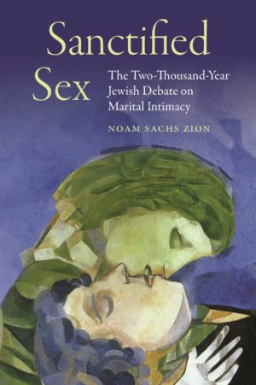
https://jps.org/books/sanctified-sex/ 276-1466-6 $36.00
- From Espionage in Talmudic Bedrooms to Contemporary Sex Ed
II. The Dark Side of Rabbinic Judaism: Rabbi Eliezer and Imma Shalom’s Bedroom Modesty and the Contemporary Hasidic Ideal of Ascetic Marriage versus
Reform Judaism’s New Vision of Marriage as a Covenantal Partnership of Lovers
III. The Litvak Revolution and the Role of Marital Communication in a Loving Relationship

Talmudic Sexual Espionage: Learning about Marital Intimacy
“Zooming Into the Bedroom” and Mandatory Rabbinic Voyeurism

Under Rav’s Bed: Kahana in the Master’s Bedroom:
“This [too] is Torah and to learn I must!"
Rav Kahana went in under Rav's bed. He heard him chatting, jesting (playing, laughing, or engaging in foreplay) and gratifying his needs.
Rav Kahana said to him: "It seems as if the mouth of Abba had never before tasted that dish!"
Rav replied: "Kahana, are you there? Get out, for it is not the way of the world [i.e. it is not good manners (derekh eretz)].
Rav Kahana answered back: “This [too] is Torah and to learn I must!"
(TB Brakhot 62a; see also TB Hagiga 5b)

The 1960s: The Generation of The Jewish Catalogue and their Ambivalence between NeoTraditionalism and the American Sexual Revolution

The Jewish Catalogue (1976): Calling for a new Halakhah and a new Aggadah
Arthur Green: We are Not Halakhic Jews!
The [Jewish] Catalog [is]. . . a reflection of the neo-traditional Jewish life-style that is evolving among certain young-in-spirit American Jews, in havurot—alternative communities. . . . While these circles have tended toward traditionalism . . . we are postmodern rather than premodern Jews, and our life-style is hardly to be considered halakhic . . . in the full sense. . . .
It is in the areas of sexual relations and the place of women that this discrepancy between fully halakhic traditionalism and the neotraditionalism of these “new Jews” is most clearly seen…..

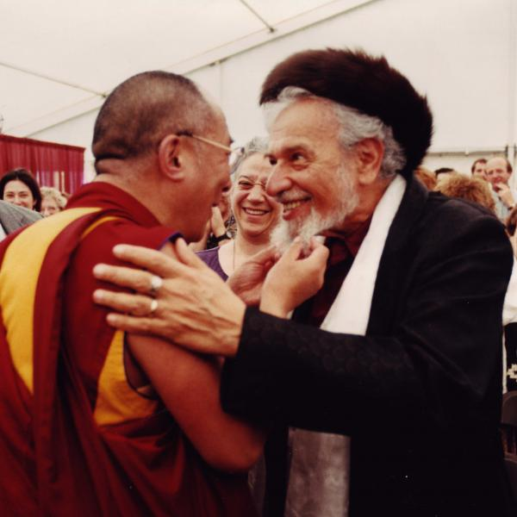

Reb Zalman Schachter-Shalomi (1924–2014): Sex and Guilt and My Habad Sex Ed
Reb Zalman: “When I was a student in the yeshiva, I remember thinking of sexuality as that lousy trick that God played on us. How could God do such a terrible thing as to implant in us an urge that is so difficult to resist? I would even get “bad thoughts” from looking at the ads for Maidenform bras that were in the subway.”

Modern Jewish Critique of the American Sexual Revolution
- Herschel Matt: The sexual revolution . . . has increased our knowledge, awareness and frankness, [and] decreased many of our fears. . . . And yet in spite of all the good in the sexual revolution . . . there is much that is bad. (The Second Jewish Catalogue)

- Eugene Borowitz: Too often our civilization is amoral about sex and not infrequently teaches shamelessness and the abolition of all guilt. It considers immediate pleasure the highest goal. By glorifying genitality and exploiting our repressions, contemporary society has largely stripped sexuality of its mysterious power to expose us to transcendence. (Choosing a Sex Ethic)

- Arthur Green: We Jews should stand opposed to the current moves toward the “demystification” of sexuality which seek to define coupling as a purely biological function. We are made most fully human by the fact that this act, shared by us with the animal kingdom, can be raised in our consciousness to the rung of . . . the sublime mystery of union. Sexuality at its fullest is brimming with religious kavanah [spiritual intentionality]. (The Second Jewish Catalogue)

The Kabbalist Inspiration for a Sacred Sexual Revolution
  - Arthur Green: Return the Neo-Kabbalah
The greatest and potentially most divine mystery accessible to most humans is the mystery of sexuality. . . . Kabbalists see the very origins of the universe as a never-ceasing process of arousal, coupling, gestation, and birth within the life of a God who is both male and female, and proclaim this complex inner flow of divinity, described in the most graphic of sexual terms, to be the highest of mysteries. All this imagery provides for the Jew an ideal of sexuality.(1976)

  - Reb Zalman: Sacred sex is the experience of ecstasy; it is the real sexual revolution. Sacred sexuality is about love—not merely the positive feeling between intimates, but an overwhelming reverence for all embodied life on whatever level of existence. . . . Sacred sexuality is about the re-enchantment of our lives. It is about embracing the imponderable mystery of existence. (1994)

  - Reb Zalman’s Alternative Sex Ed: I ask my Bar Mitzvah boys, “Do you masturbate?” And first they are a little sheepish about it and then they say, “Yes,” and I say, “You know what? It is a good thing to do on the Sabbath! Take your time, put on some music, and explore your body and what feels good for you, and most important, let God in.”
I fail my children when I cannot take them into our bedroom and show them how it’s done. Every generation learns so much from generations past about everything else, but [about] our sexuality and how to make it sacred sex - [that!] we have to pick up in the gutter? The wise elder can encourage people to make love sacramentally, transforming a physical act into prayer and celebration.

- The Biblical Mitzvah of Onah: Strengthening the Marriage Bond
(1) Ethical and Legal Responsibilities to one’s Partner;
(2) Art and Discipline of Lovemaking and Intimacy,
and (3) Pursuit of Sanctity and Spirituality
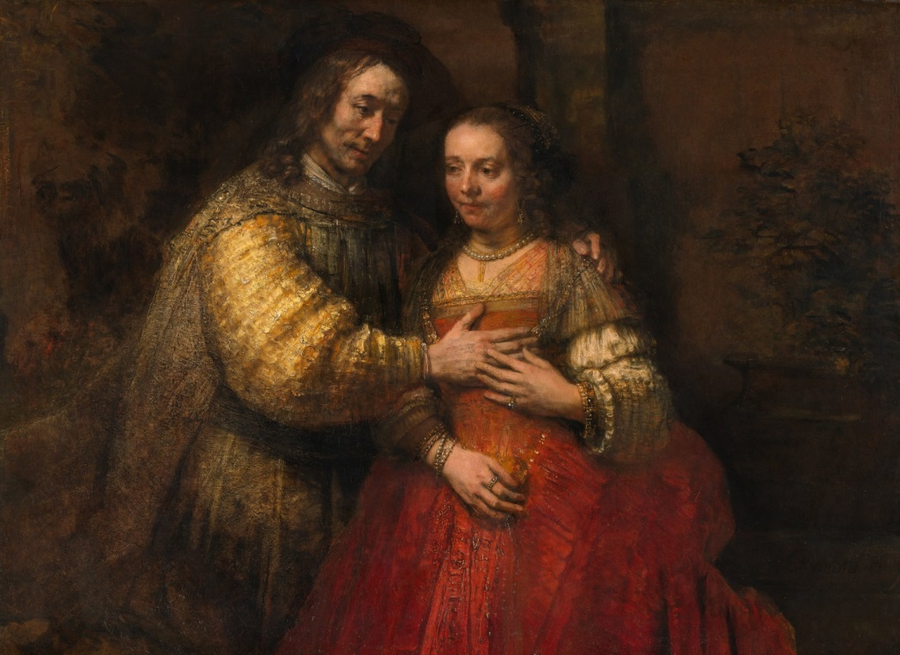
Rembrandt, “The Jewish Bride”

Mitzvat Onah: From the Husband’s Prerogative to the Wife’s Conjugal Rights
- Exodus 21:9-11: “A husband should treat his wife in accord with the law of [marriageable] women. So if he marries additional [woman], he must not deprive his first wife of her sheira, her kesut, and her onah. If he does not provide these three, she exits [the marriage]…” (Exodus 21:9b-11)
- Rashi (11th c. France): "her sh'eira, her kesut, and her onah" are her food, her clothing and her sexual intercourse.
- Ramban (13th c. Spain): (1) sh'eira is a term for a "flesh" and blood relative. It recalls Adam and Eve who became one flesh in the garden, one family. But it may also mean that she may not be deprived of the touch of flesh of her husband. He is not to follow the Persian custom of having intercourse in his clothes. (2) kesut is her bed "clothes," her linens. She must be wooed in her bed in an honorable fashion, not on the floor like a prostitute.
(3) onah is her "times" of lovemaking, regularly scheduled, even if a second wife is taken.

Maimonides (12th c. Egypt) – Wooing Your Wife Every Time
“A husband: shall not coerce her and force her into intercourse against her will (i.e. rape), but rather let him seek her consent as the outcome of conversation (sikha) and joy (simkha)” (Maimonides, Laws of Marriage 15: 17; see Laws of Character Traits 5:4).

Rav Yaakov Kanievsky the Steipler Rav:
From Mandating Affection to Demanding Gender Justice: “Don’t Rob Your own Wife” and the Ethics of Onah (Conjugal Duties)
[The Biblical law governing marriage (Exodus 21:9b-11) not only establishes a husband’s contractual obligation to provide frequent intercourse i.e., onah, but also quality sexual intimacy.] “The law of the Torah forbids intercourse between a husband and a wife in which the woman’s desires are not appeased. He must appease her with hugs and kisses until she desires the sexual union. Otherwise it is as if she is prey before a lion that tramples and devours.
It is a criminal act of exploitation to deprive a woman of her right to sexual satisfaction, even if the husband intends thereby to achieve a higher level of spirituality and asceticism. For he may not rob her [by minimizing the sexual contact to the barest act of physical intercourse] and treat her as if she were a [war] captive. [See Maimonides prohibition of marital rape].
Such a man is comparable to a thief and a robber, as he steals from his wife that which he is obliged to give her. This amounts to killing his wife, as it is known that a woman’s utmost aspiration is to have a loving husband, and when she sees that this is not the case, she is so disappointed that at times her very life is in danger, on account of her great sorrow and grief at being as lonely as a widow abandoned by her living husband.
One who grabs her and immediately has intercourse without developing emotional intimacy and then [after his ejaculation] separates himself from her immediately may think of himself as angelic [in transcending his physical being]. But actually he is still receiving his full desire and his urges are placated with complete pleasure, but his wife has not had any pleasure and she is hurting and ashamed.
So what he thinks is the highest level of spirituality is in fact a false analogy [to angels] for no one can rise to higher levels by impure and injurious sins.”Benn, Adam and Eve

Chabad missionary to Jewish students on American college campuses in the 1950s (along with “the singing rabbi,” Reb Shlomo Carlebach). After leaving Chabad and Orthodox Judaism (1962), he founded the Boston Havurah (1968). A decade later (1978) he created Bnai Or (later renamed Pnei Or to eliminate the masculine bias in the term bnai which means, literally, sons). Eventually it grew into aleph: The Jewish Renewal Movement and a seminary for neo-Hasidic Judaism that incorporated “vernacular Kabbalah” (integrating Jewish and Far Eastern meditational techniques)

